http://api.tela-botanica.org/img:000053866O.jpg

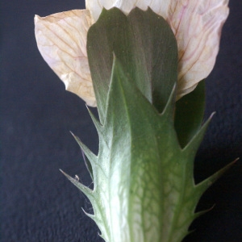

http://api.tela-botanica.org/img:000134624O.jpg



